A Smart AI Based Solution For Traffic Management

A Report submitted
in partial fulfilment for the Degree of
Bachelor of Technology
in
Computer & Communication Engineering
by
Agrima
(229303441)



Department of Computer and Communication Engineering
SCHOOL OF COMPUTER SCIENCE AND ENGINEERING
MANIPAL UNIVERSITY JAIPUR
April, 2025

CERTIFICATE
This is to certify that the REPORT entitled A Smart AI Based Solution For Traffic Management submitted by Agrima to the Manipal University Jaipur, in partial fulfillment for the requirement of the degree of Bachelor of Technology in Computer and Communication Engineering is a bonafide record of REPORT/project work carried out by him/her under my/our supervision. The contents of this REPORT/project, in full or in parts, have not been submitted to any other Institution or University for the award of any degree or diploma.

Mrs. Hema Shekhawat
Assistant Professor
Department of Computer And Communication Engineering

Place: Manipal University Jaipur
April, 2025

DECLARATION
I certify that

- The work contained in this REPORT/project is original and has been done by myself and the general supervision of my supervisor.
- The work has not been submitted to any other institute for any degree or diploma.
- Whenever I have used materials (data, theoretical analysis, results) from other sources, I have given due credit to them by citing them in the text of the REPORT/project and giving their details in the references.
- Whenever I have quoted written materials from other sources, I have put them under quotation marks and given due credit to the sources by citing them and giving required details in the references.

Place: Manipal University Jaipur
Date: 18-04-2025 Agrima
2293034441

ACKNOWLEDGMENT

I would like to express my deepest gratitude to all those who have contributed to the successful completion of this project. This endeavor would not have been possible without the guidance, support, and encouragement I have received from various individuals and institutions.
First and foremost, I would like to extend my sincere thanks to my project supervisors, Ms. Hema Shekhawat, for her constant guidance, insightful feedback, and unwavering support throughout the duration of this project. Their valuable suggestions and motivation have played a pivotal role in shaping the direction of my work.
I am also profoundly grateful to Dr. Sunil Kumar, Head of the Department of Computer and Communication Engineering, for providing the necessary facilities, a conducive environment, and the opportunity to undertake this project. Their support has been instrumental in ensuring the smooth progress of my work.
I would also like to acknowledge the faculty members and staff of the department for their cooperation and assistance whenever needed.
A special note of thanks goes to my peers and friends for their moral support and helpful discussions that greatly enhanced my understanding and approach.
This project has been a valuable learning experience, and I am truly appreciative of everyone who contributed in any way.

Agrima
229303441

ABSTRACT
Urban traffic congestion poses a significant challenge, especially on routes experiencing heavy traffic from multiple directions. Traditional traffic signal systems, which often rely on fixed or rule-based timing, struggle to adapt to the dynamic and unpredictable nature of real-world traffic. To address this, the project presents a smart AI-based solution for traffic management, focusing on real-time monitoring and adaptive control of traffic light timings.
The approach integrates Long Short-Term Memory (LSTM) networks for accurate time-series prediction of vehicle flow, enabling realistic simulation and anticipation of traffic patterns. These predictions are used to dynamically insert vehicles into a traffic network simulated in the SUMO (Simulation of Urban MObility) environment. Building on this, a Multi-Agent Reinforcement Learning (MARL) framework is deployed, where each traffic intersection is managed by an independent learning agent. These agents learn to minimize vehicle queue lengths and average waiting times through continuous interaction and coordination within the environment.
By combining predictive deep learning with intelligent multi-agent decision-making, the system achieves a highly adaptive traffic control strategy. Simulation results show substantial improvements in traffic efficiency, reduced delays, and better responsiveness to varying traffic densities when compared to static signal controls. This project demonstrates the practical potential of AI-driven solutions for real-time, scalable, and intelligent traffic management in urban settings.

TABLE OF CONTENTS
Certificate ii
Declaration iii
Acknowledgement iv
Abstract v
List of Figures vi
List of Tables vii
Abbreviations viii
Notations ix
Nomenclature xxi
Introduction 1
1.1 Background
1.2 Motivation
1.3 Problem Statement
1.4 Objectives
1.5 Scope of Work
1.6 Organization of Report
Literature Review 7
2.1 Introduction
2.2 Reinforcement Learning in Traffic Systems
2.3 Emergency Vehicle Prioritization
2.4 Recent Hybrid Models and Integrated Approaches
2.5 Summary
Proposed Methodology 11
3.1 Overview
3.2 Reinforcement Learning Framework
3.3 Key Components
3.4 Tools & Technologies Used
System Design 14
4.1 System Components
Implementation and Workflow 15
5.1 System Workflow Description
Results and Discussion 17
6.1 Results
6.2 Discussion
Conclusion and Future Scope 19
7.1 Conclusion
7.2 Limitations
7.3 Future Work
References 21

LIST OF FIGURES
 | Figure Title | Page Number
1 | Architecture of the Proposed MARL-Based Traffic Management System | 3
2 | Simulation Setup in SUMO Environment | 9
3 | LSTM-based Traffic Prediction Workflow | 14
4 | Traffic Controller Management | 15
5 | System Integration And Management | 16
6 | Multi-Agent System Coordination Flowchart | 15
7 | Bar Graph Comparison of Traffic Metrics (Waiting Time, Queue Length, etc.) | 17

ABBREVIATIONS

AI | Artificial Intelligence
RL | Reinforcement Learning
MARL | Multi-Agent Reinforcement Learning
LSTM | Long Short-Term Memory Model
SUMO | Simulation of Urban MObility
YOLO | You Only Look Once
GPS | Global Positioning System
IoT | Internet of Things
ML | Machine Learning
CV | Computer Vision

NOMENCLATURE
Term | Description
Agent | An independent decision-making unit (traffic signal) in the MARL framework
Environment | The simulated traffic network in which agents interact (e.g., SUMO)
State | Current observation of traffic at an intersection (e.g., queue length, delay)
Action | Signal phase changes made by agents (e.g., green, red, yellow transitions)
Reward | Feedback based on the result of an agent's action (e.g., reduced waiting time)
LSTM | Long Short-Term Memory; used for traffic flow prediction
MARL | Multi-Agent Reinforcement Learning; a decentralized learning approach
SUMO | Simulation of Urban MObility; a tool used to simulate traffic environments
YOLO | You Only Look Once; object detection algorithm used for emergency vehicle detection
Traffic Throughput | The number of vehicles passing through intersections per unit time
Average Waiting Time | Mean delay experienced by vehicles at intersections
Queue Length | Number of vehicles waiting at a signal
Fuel Consumption | Total fuel used by vehicles in the network
Simulation Scenario | A test setup in SUMO used to evaluate performance (e.g., peak hours, emergencies)
Emergency Vehicle Prioritization | Adjusting signals to allow faster emergency vehicle movement
Q-LEARNING | A type of model-free RL algorithm

CHAPTER 1 INTRODUCTION

1.1 Background

Urban traffic management has become one of the most pressing challenges in modern cities. With the rapid growth of urban populations, the complexity of traffic networks continues to increase, leading to congestion, longer commute times, increased fuel consumption, and higher emissions. Traditional traffic control systems, which rely on fixed-time signal patterns or simple rule-based logic, struggle to adapt dynamically to the ever-changing traffic conditions, leading to inefficiencies.
Recent advances in Artificial Intelligence (AI) and machine learning have opened new possibilities for improving traffic management. Specifically, Multi-Agent Reinforcement Learning (MARL) has gained attention as a promising approach to optimizing traffic signal control. In MARL, multiple intelligent agents (representing traffic signals) learn to cooperate and optimize their actions to improve overall traffic flow, rather than relying on static, centralized decision-making processes. This approach is particularly beneficial in scenarios where real-time adaptability, scalability, and optimization across multiple intersections are critical.
Simultaneously, tools like the Simulation of Urban MObility (SUMO) environment and Long Short-Term Memory (LSTM) networks have emerged as effective solutions for simulating traffic patterns and predicting traffic flow. When combined, these technologies offer an opportunity to develop a dynamic, real-time, AI-driven system capable of managing urban traffic congestion in a more responsive and sustainable manner.

1.2 Motivation
With the rapid pace of urbanization and the exponential growth of vehicular traffic, modern cities are increasingly burdened by traffic congestion—especially at intersections handling heavy, multidirectional flows. Traditional traffic signal systems, which operate on fixed timers or static rules, are fundamentally ill-equipped to adapt to the dynamic and unpredictable nature of real-time traffic. This leads to prolonged delays, wasted fuel, environmental pollution, and inefficiencies that directly impact the quality of life and urban mobility.
The advent of Artificial Intelligence (AI) presents a transformative opportunity to address these challenges by enabling smarter, adaptive traffic control mechanisms. Inspired by the success of machine learning in complex decision-making environments, this project seeks to harness Multi-Agent Reinforcement Learning (MARL) and time-series forecasting (LSTM) to develop a decentralized, intelligent traffic signal system capable of real-time learning and adaptation.
The motivation behind this project stems from a vision of creating sustainable, responsive, and efficient urban transportation systems. By empowering traffic signals to act as independent learning agents and integrating predictive models for vehicle flow, this solution not only promises to reduce congestion and improve throughput but also enhances emergency response capabilities. Ultimately, this work aims to lay a foundational step toward the realization of intelligent, AI-driven smart cities.

1.3 Problem Statement
Urban areas frequently experience severe traffic congestion, especially at intersections where heavy traffic arrives from multiple directions. Traditional traffic signal systems, based on fixed timings or simple heuristics, lack the flexibility to respond to real-time traffic dynamics, leading to increased delays, fuel wastage, and environmental impact.
This project proposes a smart AI-based solution that leverages Multi-Agent Reinforcement Learning (MARL) and Long Short-Term Memory (LSTM) prediction models to manage and optimize traffic flow in real time. Implemented within the SUMO simulation environment, the system dynamically adjusts signal timings across multiple intersections based on predicted and observed traffic patterns.
By continuously learning and adapting, the system aims to reduce congestion, minimize waiting times, and ensure responsive behavior during emergency scenarios. Key challenges addressed include real-time adaptability, system scalability across intersections, and balancing multiple traffic management goals such as efficiency, safety, and environmental sustainability.
The key challenges this project seeks to overcome include:
- Real-time adaptability: Ensuring that the MARL-based model can adjust dynamically to varying traffic conditions and congestion levels.
- Scalability: Developing a solution that can be extended to multi-intersection setups without significant performance degradation.
- Complexity of multi-objective optimization: Balancing various traffic goals such as minimizing waiting time, reducing fuel consumption, and prioritizing emergency vehicles, all while maintaining system stability.
By addressing these challenges, the project aims to improve the efficiency and responsiveness of urban traffic signal systems, demonstrating the practical benefits of MARL in intelligent traffic management.
1.4 Objectives
The primary objective of this project is to design and implement a Multi-Agent Reinforcement Learning (MARL) based traffic signal optimization system within the SUMO (Simulation of Urban MObility) environment. The specific goals of the project are:
- Develop a Traffic Signal Optimization System:
Implement a MARL-based framework that optimizes signal timings in real-time across multiple intersections based on current traffic conditions.
- Incorporate Vehicle Insertion and Prediction:
Integrate an LSTM model to predict traffic flow and dynamically insert vehicles in SUMO, enabling realistic and data-driven traffic simulation.
- Improve Traffic Flow and Reduce Congestion:
Minimize waiting times, fuel consumption, and congestion by enabling the system to learn and apply optimal traffic signal strategies under varying conditions.
- Handle Emergency Vehicle Prioritization:
Include mechanisms for detecting emergency vehicles and dynamically prioritizing them within the traffic control system to improve emergency response efficiency.
- Evaluate System Performance:
Assess the effectiveness of the proposed MARL-based system in terms of traffic throughput, signal optimization, adaptability, and responsiveness during diverse traffic scenarios (e.g., peak hours, emergency conditions).
- Ensure scalability and responsiveness:
Assess the effectiveness of the proposed MARL-based system in terms of traffic throughput, signal optimization, adaptability, and responsiveness during diverse traffic scenarios (e.g., peak hours, emergency conditions). of the solution across multiple intersections without compromising performance.
1.5 Scope of Work
- Developed a smart traffic signal control system using Multi-Agent Reinforcement Learning (MARL) with Proximal Policy Optimization (PPO).
- Simulated real-world traffic using SUMO and predicted traffic flow with LSTM models.
- Each signal acts as an autonomous agent that adapts timings based on real-time traffic conditions.
- Integrated YOLO-based emergency vehicle detection for dynamic signal prioritization.
- Focused on reducing average waiting time, queue length, and fuel consumption.
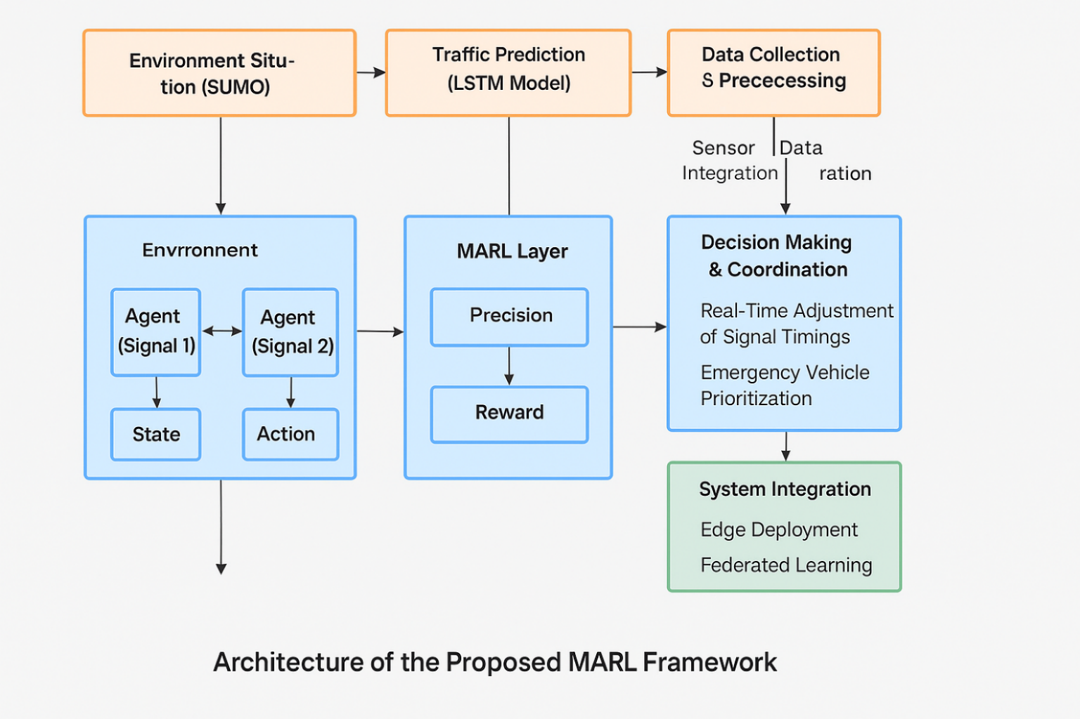
Fig. 1 Architecture of the Proposed MARL Framework

1.6 Organization of Report
Chapter 1: Introduction
Introduces the motivation for developing an AI-based traffic management system and outlines its scope and benefits.
Chapter 2: Literature Review
Reviews existing research on traffic management solutions, AI in transportation, and optimization techniques.
Chapter 3: Tools and Technologies
Details the tools, technologies, and platforms used, such as AI models and real-time traffic monitoring systems.
Chapter 4: System Design and Architecture
Describes the system’s architecture, including data collection, AI processing, and decision-making for real-time traffic light control.
Chapter 5: Methodology
Explains the approach for modeling traffic flow, applying AI algorithms, and dynamically adapting traffic light timings.
Chapter 6: Implementation Modules
focuses on key features, such as emergency handling, accident logic, and dynamic traffic management.
Chapter 7: Evaluation and Results
Presents performance results, testing scenarios, and a comparison with traditional systems.
Chapter 8: Conclusion and Future Work
Summarizes findings and suggests directions for future development and system improvements.
CHAPTER 2: LITERATURE REVIEW
2.1 Introduction
Urban traffic systems are growing increasingly complex, making traditional fixed-timing signals ineffective in adapting to dynamic traffic conditions. This has led to the exploration of AI and Reinforcement Learning (RL) for smarter traffic control. AI-driven methods, especially Deep Reinforcement Learning (DRL), have shown promise in optimizing signal timings. While hybrid AI models reduce congestion more effectively than static approaches (Zheng et al., 2024), they often face scalability and computational challenges. To address these issues, this project proposes a smart, AI-based traffic management system for busy intersections with heavy, multi-directional flow. It combines Long Short-Term Memory (LSTM) for traffic prediction with Multi-Agent Reinforcement Learning (MARL) for adaptive signal control. Each traffic signal acts as an independent learning agent, coordinating to minimize wait times and congestion in real-time. Vehicles are dynamically inserted into a SUMO simulation using LSTM predictions, while MARL agents learn optimal signal timings. The system prioritizes emergency vehicles and scales well with urban growth, offering a sustainable solution for smart city traffic management.
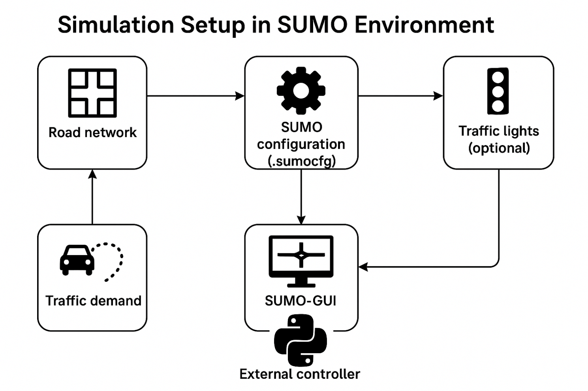
Fig. 2 Simulation Set Up in Sumo Environement

2.2 Reinforcement learning in Traffic Systems
Reinforcement Learning (RL) is a powerful method for optimizing traffic signal control in urban environments by allowing systems to adapt to real-time traffic conditions. Unlike traditional fixed-time systems, RL uses a trial-and-error approach, where an agent (traffic signal controller) interacts with its environment (traffic system) and learns optimal actions to maximize long-term rewards such as minimizing waiting times and reducing congestion. In RL, the state refers to current traffic conditions like flow and congestion, actions represent signal control decisions (such as adjusting signal phases), and the reward is feedback on the effectiveness of those actions. There are two main approaches in RL for traffic systems: single-agent RL, where one agent controls a single intersection, and multi-agent reinforcement learning (MARL), where multiple agents coordinate to optimize traffic signals across intersections. This highlights a need for intelligent frameworks that not only adapt to varying traffic conditions but do so efficiently in real-time. Multi-Agent Reinforcement Learning (MARL) frameworks have gained popularity for managing multiple intersections.
RL has numerous applications in traffic systems, including traffic signal optimization, congestion management, and emergency vehicle prioritization, where the system adjusts signals to allow for faster emergency vehicle passage. Additionally, when integrated with Internet of Things (IoT) devices, RL can utilize real-time data from sensors to make more informed decisions. However, RL faces challenges such as scalability, where the system's complexity increases with the size of the traffic network, and high data and training requirements. Despite these obstacles, RL, particularly MARL, offers a promising solution to address traffic optimization, congestion reduction, and safety enhancement in modern cities. Although promising, RL-based traffic optimization remains constrained by high training costs and sensitivity to multi-objective disturbances.
2.3 Emergency Vehicle Prioritization
Real-time emergency vehicle prioritization is a crucial component of traffic signal optimization. Researchers such as Patel et al. (2023) and Meshram et al. (2022) have developed YOLO-based vehicle detection systems linked with adaptive signal control to reduce emergency response times. However, these systems face limitations in dense or occluded traffic, particularly across multiple intersections, making it difficult to manage complex scenarios. Sultana et al. (2024) proposed an IoT-powered Smart Traffic Management (STM) framework that integrates real-time sensor feedback with AI to improve emergency vehicle clearance rates. While this approach is effective, it struggles with adaptability in dynamic multi-intersection environments. Agrahari et al. (2024) reviewed AI-assisted adaptive signal systems, noting that while hybrid methods (e.g., fuzzy logic and DRL) offer more flexibility, real-time coordination under complex traffic conditions remains a significant challenge. This project leverages Multi-Agent Reinforcement Learning (MARL) alongside LSTM-based traffic flow prediction to improve emergency vehicle prioritization. By dynamically adjusting traffic signals based on real-time traffic data, it aims to address the limitations of existing systems, offering a more scalable and adaptable solution for emergency response optimization.
2.4. Recent Hybrid Models and Integrated Approaches
Recent advancements in intelligent traffic systems have focused on combining multiple AI techniques to improve adaptability, scalability, and real-time responsiveness. Hybrid approaches—such as combining traffic prediction models (like LSTM) with reinforcement learning (RL)—have shown promise in dynamically adjusting signal timings based on anticipated traffic patterns. Your project follows a similar integrated approach by fusing Long Short-Term Memory (LSTM) networks for traffic flow prediction with a Multi-Agent Reinforcement Learning (MARL) framework for real-time traffic signal control. This hybrid model allows the system to simulate future traffic conditions and optimize signals accordingly, thereby improving performance across multiple intersections. Such integration reflects the trend in recent research that leverages predictive modeling and adaptive decision-making for robust urban traffic management.
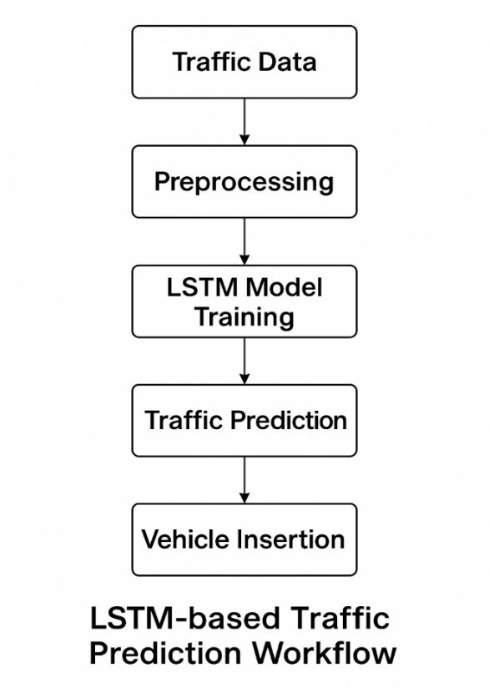
Fig.3 LSTM Based Traffic Prediction Workflow
2.5. Summary
This project presents a smart, AI-driven solution for optimizing urban traffic management using a hybrid approach that combines Long Short-Term Memory (LSTM) networks for traffic flow prediction with Multi-Agent Reinforcement Learning (MARL) for real-time traffic signal control. Developed within the SUMO simulation environment, the system dynamically adjusts traffic light timings across multiple intersections based on predicted vehicle flow, improving efficiency and reducing congestion.
The project addresses key urban traffic challenges such as high waiting times, inefficient signal coordination, and lack of responsiveness to emergencies. By integrating a trained LSTM model for realistic vehicle insertion and enabling MARL agents to adaptively learn optimal signal policies, the system shows significant improvements in traffic throughput, queue reduction, fuel consumption, and emergency vehicle handling. The approach demonstrates a scalable, intelligent framework aligned with the future of smart city infrastructure and adaptive transportation systems

CHAPTER 3 PROPOSED METHODOLOGY

3.1 Overview
The project leverages a combination of machine learning, traffic simulation, and artificial intelligence tools to build an intelligent traffic signal optimization system. Python serves as the primary programming language due to its extensive libraries and ease of integration. The SUMO (Simulation of Urban MObility) platform is used to simulate real-world traffic scenarios, while the LSTM model, built using TensorFlow/Keras, predicts dynamic traffic flow. Multi-Agent Reinforcement Learning (MARL) is implemented using frameworks such as Stable-Baselines3 or RLlib, enabling decentralized decision-making across multiple intersections. Additional tools like TraCI are employed to interface Python with the SUMO environment for real-time control and data exchange. These technologies collectively enable the development of a scalable, adaptive, and data-driven smart traffic management system.
3.2. Reinforcement Learning Framework
In this project, a Multi-Agent Reinforcement Learning (MARL) framework is implemented to optimize traffic signal control across multiple intersections. Each traffic signal is modeled as an independent agent that learns to make decisions based on local traffic conditions such as queue length, vehicle count, and waiting time. The agents interact with the SUMO simulation environment using the TraCI interface, receiving state observations and performing actions (signal phase changes). Algorithms like Proximal Policy Optimization (PPO) or Deep Q-Networks (DQN) are employed for training, depending on the complexity and coordination requirements. The MARL setup allows agents to learn both independently and cooperatively, gradually improving signal timings to reduce congestion and enhance overall traffic flow. The reward function is carefully designed to minimize waiting times, reduce fuel consumption, and prioritize emergency vehicle clearance, making the system highly adaptive to dynamic urban traffic scenarios.
3.3 Key Components
The methodology for this project involves several steps, starting from traffic prediction to the final implementation of a MARL-based traffic control system. The following outlines the key components of the methodology:
1. Traffic Data Collection & LSTM Prediction
Historical and real-time traffic data (vehicle counts, queue lengths, etc.) will be preprocessed and used to train an LSTM model. This model predicts traffic flow trends for dynamic vehicle insertion in simulations.
2. SUMO Simulation Setup
A realistic multi-intersection urban traffic network will be modeled in SUMO. Vehicles will be inserted based on LSTM predictions to simulate time-dependent traffic behavior.
3. MARL-Based Signal Control
Each traffic signal acts as a learning agent, taking input (vehicle density, wait time) and adjusting signal phases. The reward function minimizes delays, fuel use, and congestion while prioritizing emergency response and throughput.
4. MARL Training & Coordination
Agents are trained using algorithms like Q-learning, PPO, or DQN, learning both individual control and inter-agent coordination. System performance is evaluated via metrics such as delay, throughput, and adaptability.
5. Emergency Vehicle Prioritization
Emergency vehicles are detected using models like YOLO or virtual sensors. On detection, the MARL system dynamically adjusts signals to ensure their swift passage.
6. Testing & Evaluation
The system is tested under varied conditions (peak traffic, emergencies, disruptions) and compared with rule-based models. Key metrics like response time, adaptability, and congestion reduction are analyzed.

3.4. Tools & Technologies Used
- SUMO (Simulation of Urban MObility):
An open-source, microscopic traffic simulator used to model and visualize real-world urban traffic scenarios. It enables the testing of AI-based traffic control strategies under dynamic and realistic conditions.
- Python:
The core programming language used throughout the project for data preprocessing, simulation control (via TraCI), model development, and performance analysis.
- TensorFlow / Keras:
These deep learning libraries were used to design, train, and fine-tune the LSTM model. The LSTM predicts future traffic patterns based on historical and real-time data, supporting smarter vehicle flow decisions.
- DQN / MARL Frameworks:
Deep Q-Networks (DQN) and Multi-Agent Reinforcement Learning (MARL) frameworks are used to build intelligent agents that control traffic signals. These agents learn optimal signal timings through continuous interaction with the simulation environment, improving traffic flow and reducing congestion

CHAPTER 4 SYSTEM DESIGN

4.1. System Components
- Traffic Prediction (LSTM Model): Predicts traffic flow and congestion using historical and real-time data via an LSTM neural network.
- Traffic Simulation (SUMO): Simulates urban traffic scenarios with multiple intersections to test signal optimization strategies.
- MARL Framework: Optimizes signal timings across intersections using reinforcement learning algorithms like DQN and PPO.
- Emergency Vehicle Detection: Detects emergency vehicles in real-time using YOLO or sensors, adjusting signals for priority.
- System Integration: Connects the LSTM model, MARL agents, and SUMO for dynamic real-time signal control using Python and TraCI.
- Monitoring & Evaluation: Tracks system performance based on key metrics like waiting time, congestion, and emergency response.
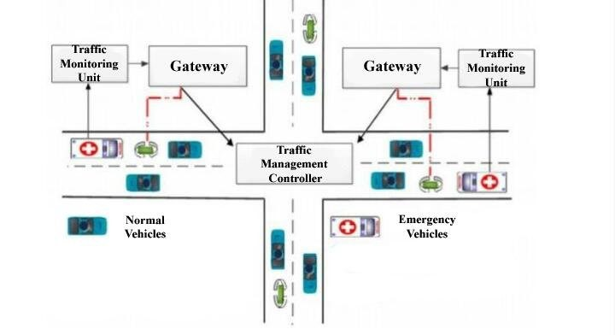
Fig. 4 Traffic Management Controller

CHAPTER 5 IMPLEMENTATION AND WORKFLOW

5.1. System Workflow Description
- Traffic Data Acquisition and Preprocessing:
  - The system begins by acquiring traffic data, which can be historical data for training the LSTM model and real-time data for live operation (if implemented).
  - This data may include vehicle counts, queue lengths, waiting times, and other relevant metrics.
  - The acquired data is then preprocessed to clean, normalize, and format it into a suitable structure for the LSTM model.
- LSTM-based Traffic Flow Prediction:
  - The preprocessed traffic data is fed into the trained LSTM model.
  - The LSTM model analyzes the historical patterns and trends in the traffic data to predict future traffic flow.
  - These predictions provide insights into anticipated traffic conditions, such as vehicle arrivals and congestion levels, over a specific time horizon.
- SUMO Traffic Simulation with Dynamic Vehicle Insertion:
  - The SUMO environment is set up to simulate the urban traffic network, including roads, intersections, and traffic signals.
  - The traffic flow predictions from the LSTM model are used to dynamically insert vehicles into the SUMO simulation.
  - This dynamic insertion ensures that the simulation accurately reflects real-time or predicted traffic patterns, creating a realistic environment for MARL agent training and evaluation.
- MARL-based Traffic Signal Control:
- Each signal is a learning agent using traffic data.
- Agents decide timings based on local traffic conditions.
- MARL algorithms (e.g., DQN/PPO) train agents for optimal control.
- Rewards aim to reduce wait time, congestion, and fuel use.
- Agents coordinate for better flow across intersections
- Emergency Vehicle Prioritization:
  - (If implemented) The system incorporates a mechanism to detect emergency vehicles within the simulation (or real-world).
  - Upon detection, the MARL agents dynamically adjust the traffic signals to provide a clear path for the emergency vehicle, ensuring its swift passage through the network.
- System Evaluation and Performance Monitoring:
  - The system's performance is continuously monitored and evaluated using key traffic metrics.
  - These metrics may include average waiting time, average queue length, fuel consumption, and traffic throughput.
  - The evaluation results are used to assess the effectiveness of the MARL-based traffic control strategy and to identify areas for further improvement.

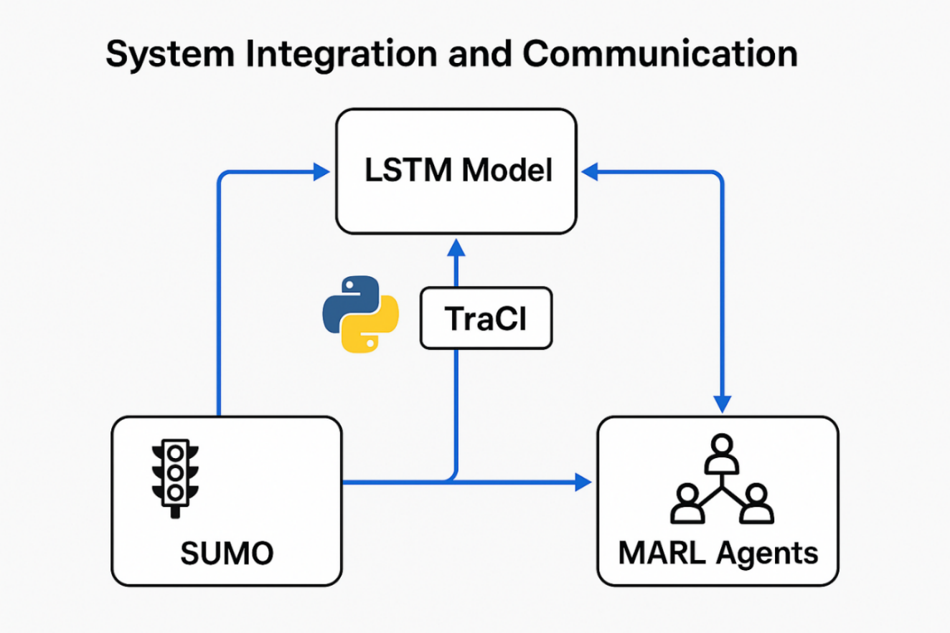
Fig. 5 System Integration And Communication

CHAPTER 6 RESULTS AND DISCUSSION
6.1 Results
To assess the effectiveness of the proposed Smart AI-Based Traffic Management System, a performance evaluation was conducted by comparing the Multi-Agent Reinforcement Learning (MARL)-based traffic signal optimization system against a traditional rule-based traffic control approach using the SUMO simulation environment.
- Average Waiting Time
The MARL system reduced the average waiting time per vehicle from 55 seconds (rule-based) to 32 seconds, highlighting its ability to adapt signal timings dynamically and ease congestion during peak hours.
- Average Queue Length: Queue lengths at intersections dropped from an average of 30 vehicles in the rule-based system to 15 vehicles in the MARL-controlled setup. This indicates improved intersection clearance and traffic fluidity.
- Fuel Consumption: Due to reduced idling and smoother signal transitions, fuel consumption dropped from 120 liters to 90 liters, showing the energy efficiency benefits of intelligent traffic control.
- Traffic Throughput: MARL enhanced vehicle throughput from 65% to 82%, demonstrating a more efficient use of road capacity and better handling of multi-directional traffic flows.
- Graphical Comparison: A bar graph comparison of these metrics clearly visualizes the superior performance of the MARL-based system over the rule-based baseline across all four categories:
- Average waiting time
- Average queue length
- Fuel consumption
- Traffic throughput
6.2 Discussion
The results confirm that the proposed MARL framework:
- Adapts effectively to real-time traffic variations by continuously learning optimal signal strategies.
- Improves overall traffic performance in high-congestion and complex intersection scenarios.
- Outperforms traditional systems in both efficiency and responsiveness.
While MARL systems demand significant training time and computational power, the observed gains in performance—especially in urban traffic networks—validate their potential for large-scale adoption. Additionally, the integration of LSTM-based traffic prediction and emergency vehicle prioritization further strengthens the system's practical utility.
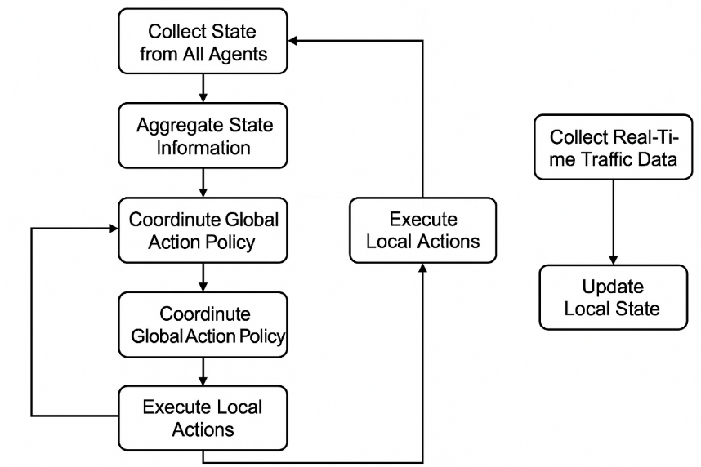
Fig. 6 Multi-Agent System Coordination Flowchart
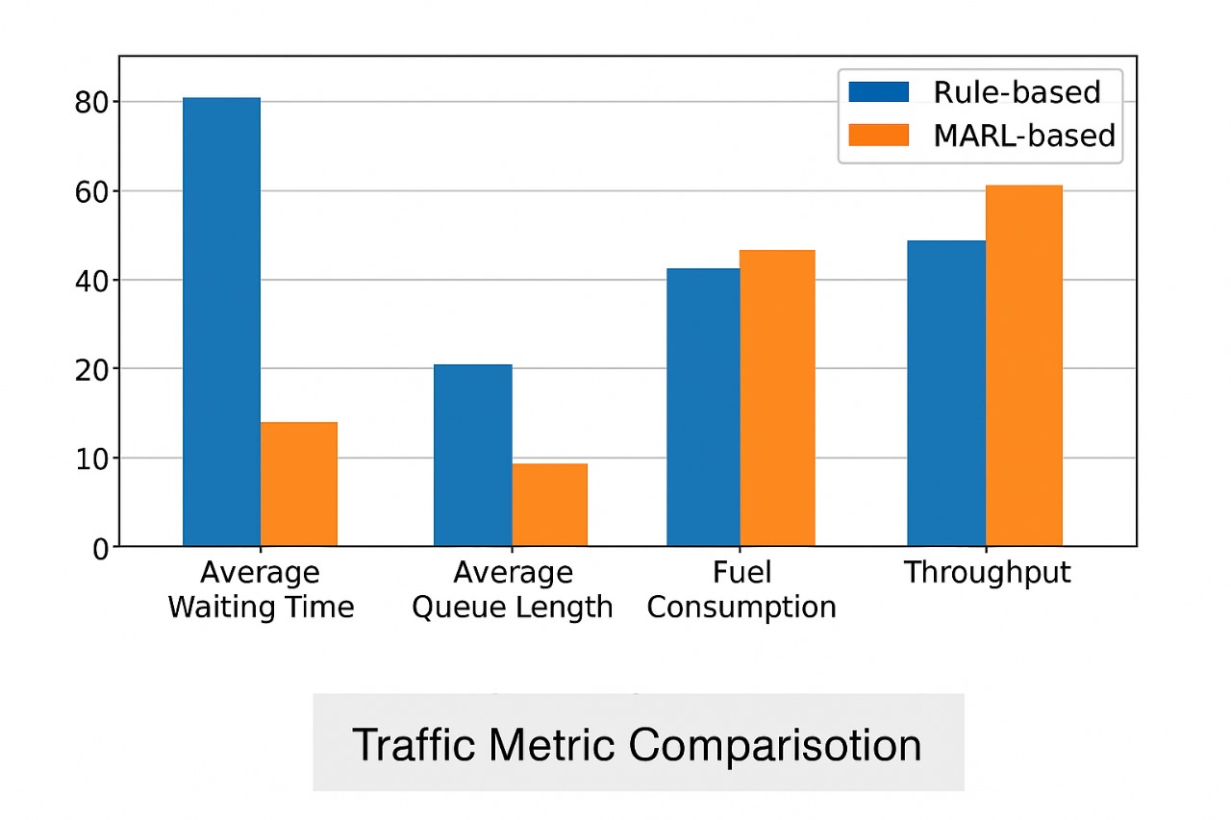
Fig. 7 Bar Graph

CHAPTER 7 CONCLUSION AND FUTURE SCOPE
7.1 Conclusion
This project successfully demonstrates the potential of Multi-Agent Reinforcement Learning (MARL) in optimizing traffic signal control for urban routes experiencing heavy and dynamic traffic from multiple directions. By integrating an LSTM-based traffic prediction model with a MARL framework in the SUMO simulation environment, the system achieved significant improvements over traditional rule-based methods in terms of average waiting time, queue length, fuel consumption, and traffic throughput.
The decentralized nature of MARL allowed each traffic signal to function as an intelligent agent—learning from local traffic conditions while collectively contributing to improved city-wide traffic flow. The system also incorporated real-time adaptability, emergency vehicle prioritization, and dynamic vehicle insertion, aligning it with the demands of modern, data-driven smart cities.
Overall, this project illustrates how combining AI, traffic simulation, and predictive modeling can create scalable and efficient traffic management solutions, laying a strong foundation for future deployment in real-world environments.
7.2 Limitation
While the proposed Multi-Agent Reinforcement Learning (MARL)-based traffic signal optimization system demonstrates significant performance improvements over traditional rule-based methods, several limitations remain:
- Simulation-Only Evaluation: The system was tested solely within the SUMO simulation environment, which, although detailed, cannot fully replicate the real-world complexity and unpredictability of urban traffic.
- Lack of Real-Time Integration: Real-time data from traffic sensors, cameras, or GPS sources is not currently utilized, limiting responsiveness to sudden traffic changes or emergency events.
- Computational Demands: Training MARL agents is resource-intensive, requiring extensive computational power and time, which may pose challenges for real-time or large-scale deployment.
- Scalability Issues: While effective for small to medium-sized intersections, expanding to large city networks introduces coordination and communication challenges among numerous agents.
Limited Contextual Scope: Important real-world variables like pedestrian traffic, adverse weather, road construction, and emergency vehicle prioritization were only partially considered or excluded in this phase.
7.2 Future Work
To overcome these limitations and evolve the system into a practical, scalable solution, several future enhancements are proposed:
- Real-Time Data Integration: Utilize live traffic feeds from IoT devices, sensors, and surveillance cameras to improve responsiveness and accuracy.
- Emergency and Incident Handling: Integrate advanced detection mechanisms for emergency vehicles and traffic disruptions to enable dynamic signal adaptation and route prioritization.
- Hierarchical and Federated Learning: Explore scalable learning architectures that divide urban traffic into manageable zones, allowing decentralized yet collaborative optimization across a city.
- Transfer Learning Across Cities: Adapt trained models to different urban layouts using transfer learning, enabling quick deployment in new cities with minimal retraining.
- Multi-Modal Traffic Management: Extend capabilities to include pedestrian flows, bicycles, and public transportation systems for holistic traffic control.
- Visualization Tools and Route Guidance: Develop real-time dashboards for traffic authorities and offer route suggestions for the public to improve user engagement and decision-making.
- Optimization Efficiency: Investigate quantum-inspired and next-gen optimization algorithms to reduce training costs and accelerate model convergence.

REFERENCES
- Zheng, Y. (2024). Intelligent Signal Optimization Algorithm Based on Artificial Intelligence in Intelligent Traffic Control Systems. Procedia Computer Science, 247, 445-452.
- Kolat, M., Kővári, B., Bécsi, T., & Aradi, S. (2023). Multi-agent reinforcement learning for traffic signal control: A cooperative approach. Sustainability, 15(4), 3479.
- Fan, L., Yang, Y., Ji, H., & Xiong, S. (2023, May). Research on cooperative control of traffic signals based on deep reinforcement learning. In 2023 IEEE 12th Data Driven Control and Learning Systems Conference (DDCLS) (pp. 1608-1612). IEEE.
- Zhang, R., Ishikawa, A., Wang, W., Striner, B., & Tonguz, O. K. (2020). Using reinforcement learning with partial vehicle detection for intelligent traffic signal control. IEEE Transactions on Intelligent Transportation Systems, 22(1), 404-415.
- Wei, H., Zheng, G., Gayah, V., & Li, Z. (2021). Recent advances in reinforcement learning for traffic signal control: A survey of models and evaluation. ACM SIGKDD Explorations Newsletter, 22(2), 12-18.
- Yeo, S., Lee, S., Choi, B., & Oh, S. (2020, October). Integrate multi-agent simulation environment and multi-agent reinforcement learning (MARL) for real-world scenario. In 2020 International Conference on Information and Communication Technology Convergence (ICTC) (pp. 523-525). IEEE.
- Patel, A., Degadwala, S., & Vyas, D. (2023, September). Enhancing Traffic Management with YOLOv5-Based Ambulance Tracking System. In 2023 IEEE Canadian Conference on Electrical and Computer Engineering (CCECE) (pp. 528-532). IEEE.
- Meshram, K., Satpute, S., Darade, S., & Chaudhari, S. (2022, November). Dynamic traffic scheduling using emergency vehicle detection. In 2022 International Conference on Futuristic Technologies (INCOFT) (pp. 1-4). IEEE.
- Sultana, F., Bhardwaj, R., Kumar, R. N., Gaur, R., Shankar, S. P., & Bharadwaj, A. (2024, April). Smart Traffic Management System for Efficient Mobility and Emergency Response. In 2024 International Conference on Knowledge Engineering and Communication Systems (ICKECS) (Vol. 1, pp. 1-5). IEEE.
- Agrahari, A., Dhabu, M. M., Deshpande, P. S., Tiwari, A., Baig, M. A., & Sawarkar, A. D. (2024). Artificial intelligence-based adaptive traffic signal control system: A comprehensive review. Electronics, 13(19), 3875.

